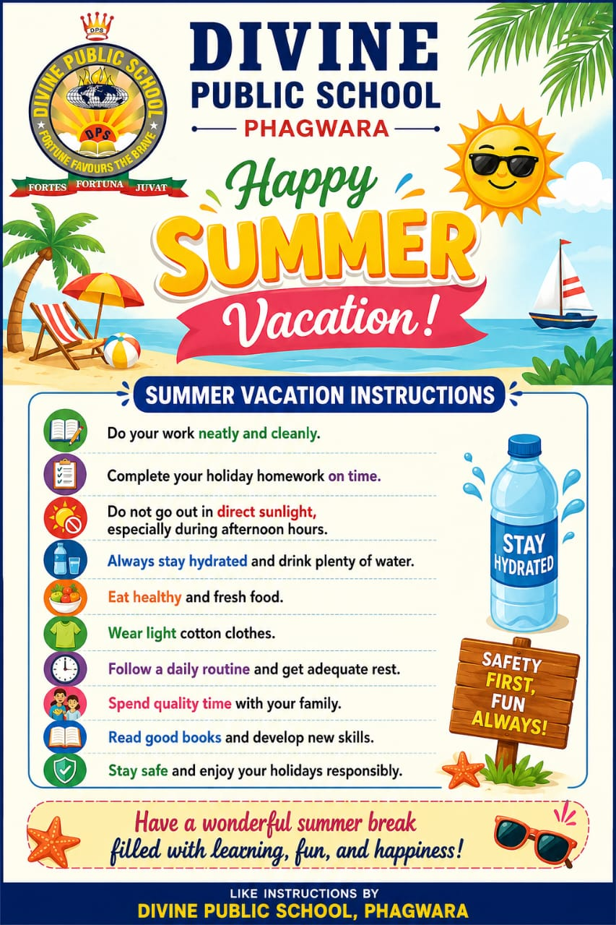

SCIENCE
Activity 1 ( to be done in Science Notebook)
- Classification of Substances
Prepare a list of 10 substances commonly found at home.
Classify each substance into one of the following categories:
- Element
- Compound
- Mixture

Activity 2 ( to be done in Science notebook)
- Family Survey
Conduct a small survey of 10 family members, relatives, or neighbours and record their responses to the
following questions:
- Do they prefer using wet waste and dry waste bins separately?
- Do they plant or care for trees and plants?
- Do they reuse or recycle materials at home?

Roll No 1-5
Model: rainwater harvesting model

Roll No 6-10
Model: traffic management system

Roll No. 11-15
Model: Future Earth- save environment

Roll No 16-20
Model: eco friendly village

HINDI
गमले में एक पौधा लगाइए और उसकी देखभाल कीजिए उसके साथ अपनी एक फोटो लगाकर उसके बारे में अपनी
कॉपी में लिखें। Roll No. 1 to 9
जल ही जीवन है" विषय पर एक सुंदर पोस्टर बनाइए Roll No.1 to 18
Revise short grammar of pt 1.

ENGLISH
READING- Read any story of your choice and write:
Character sketch of the main character,
Moral of the story and Your favorite scene.
WRITING-1. Paragraph Writing on
A Memorable Holiday Trip
2. Diary Entry
Write a diary entry on: “The happiest day of my summer vacation.”
3. Letter Writing
Write an informal letter to your friend describing how you spent your holidays.
4. Story Writing

Complete the story using the hints:
“It was raining heavily. I was alone at home when suddenly the lights went out…”

GRAMMAR - Tenses,
Active and Passive Voice, Direct and Indirect Speech
Activity
Make a colorful grammar chart on any one topic.
Listening - Listen English news for 10 minutes daily.
Speaking - Prepare a 1–2 minute speech on any one topic

PUNJABI

Roll Number 1 to 5

Model : ਪੰਜਾਬੀ ਸਾਹਿਤਕਾਰਾਂ ਦੀ ਗੇਲਰੀ
ਸਮਾਨ: ਚਾਰਟ ਪੇਪਰ, ਪ੍ਰਿੰਟ ਕੀਤੀਆਂ ਤਸਵੀਰਾਂ, ਰੰਗੀਨ ਕਾਗਜ਼।
ਬਣਾਉਣ ਦਾ ਤਰੀਕਾ:
ਬੋਰਡ ਤੇ 5 ਖਾਣੇ ਬਣਾਓ।
ਵਾਰਿਸ ਸ਼ਾਹ, ਬੁੱਲੇ ਸ਼ਾਹ, ਅਮ੍ਰਿਤਾ ਪ੍ਰੀਤਮ, ਸ਼ਿਵ ਕੁਮਾਰ ਬਟਾਲਵੀ, ਸੁਰਜੀਤ ਪਾਤਰ ਦੀਆਂ ਤਸਵੀਰਾਂ ਲਗਾਓ।
ਵਰਤੋਂ:
8ਵੀਂ ਦੇ ਪਾਠ-ਪੁਸਤਕ ਵਾਲੇ ਲੇਖਕਾਂ ਬਾਰੇ ਦੱਸਣ ਲਈ।

Roll Number 6 to 10

Model : ਪੰਜਾਬੀ ਅਖਾਣਾਂ ਦਾ ਚੱਕਰ – Working Model
ਸਮਾਨ:
2 ਗੱਤੇ ਦੇ ਚੱਕਰ, ਸਪਲਿਟ ਪਿੰਨ, ਸਕੇਚਰ।
ਬਣਾਉਣ ਦਾ ਤਰੀਕਾ:
ਹੇਠਲੇ ਚੱਕਰ ਤੇ 8 ਅਖਾਣ ਲਿਖੋ। ਉੱਤੇ ਵਾਲੇ ਚੱਕਰ ਤੇ 8 ਖਿੜਕੀਆਂ ਕੱਟੋ ਜਿਸ ਵਿੱਚ ਅਰਥ ਦਿਸੇ। ਚੱਕਰ ਘੁਮਾਉਣ ਤੇ ਅਖਾਣ ਦਾ
ਅਰਥ ਮਿਲੇ।
Example:
“ ਅੱਗ ਲੱਗੇ ਤੇ ਖੂਹ ਪੁੱਟਣਾ” → “ਮੁਸੀਬਤ ਵੇਲੇ ਤਿਆਰੀ ਕਰਨਾ”

Roll Number 11 to 18

Model : ਪੰਜਾਬੀ ਵਿਆਕਰਨ ਦੀ ਰੇਲਗੱਡੀ
ਸਮਾਨ:
ਜੁੱਤੀਆਂ ਦੇ ਡੱਬੇ, ਧਾਗਾ, ਰੰਗ।
ਬਣਾਉਣ ਦਾ ਤਰੀਕਾ:
ਇੰਜਣ = “ਵਿਆਕਰਨ”।
5 ਡੱਬੇ = ਨਾਂਵ, ਪੜਨਾਂਵ, ਵਿਸ਼ੇਸ਼ਣ, ਕਿਰਿਆ, ਮੁਹਾਵਰੇ।
ਹਰ ਡੱਬੇ ਤੇ ਪਰਿਭਾਸ਼ਾ + 3 ਉਦਾਹਰਨਾਂ ਲਿਖੋ।
ਬੱਚਿਆਂ ਨੂੰ ਧਾਗੇ ਨਾਲ ਜੋੜੋ।

MATHEMATICS
Instructions:
• Complete all work neatly in your Mathematics notebook.
• Show complete steps.
• Use colours wherever required.
• Submit homework after holidays.

Part A: A Square and a Cube
Q1. Find the squares of: a) 24
b) 35 c) 48
Q2. Find the cubes of:
a) 5 b) 9 c) 12
Q3. Write whether the following are perfect squares:
121, 169, 225, 180
Q4. Find the square root of:
a) 144 b) 400 c) 625
Q5. Solve:
a) Area of a square with side 15 cm
b) Volume of a cube with side 8 cm

Activity ■
Prepare a table of first 20 square numbers and first 10 cube numbers.

Part B: Power Play Q6.
Write in exponential form:
a) 2×2×2×2
b) 5×5×5
Q7. Expand:
a) 3^4 b) 10^3 c) 7^2
Q8. Simplify:
a) 2^3 × 2^2
b) 5^4 ÷ 5^2
Q9. Fill in the blanks:
a) 10^0 = ____
b) 3^1 = ____

Challenge Corner ■
1. Create 5 questions based on exponents and solve them.
2. Find examples of squares and cubes used in daily life.

Model Making Activity (Summer Vacation Holiday Homework):
Students will prepare one mathematics model in a team by freely choosing any topic from the
list given below. The activity aims to encourage teamwork, creativity, and practical.
understanding of mathematical concepts. The model should be neat, attractive, and
innovative, and must be submitted after the summer vacation along with the holiday homework.

1. 3D Cube Volume Model
2. Power Wheel Model

3. Square Root Wheel
4. Exponent Tree Model
5. Perfect Square Pyramid
6. Laws of Exponents Flip Chart
7. Square and Cube Number Chart
8. Magic Square Puzzle Model
9. Exponential Growth Tree Model
10. Number Tower of Squares and Cubes
11. Power Cards Activity Model
12. Interactive Exponents Board
13. Daily Life Examples of Squares and Cubes Model
14. Cube Net Folding Model
15. Square Root Matching Game Model
16. Mathematics Wheel of Powers
17. 3D Shapes with Squares and Cubes Model
18. Perfect Square Identification Chart
19. Exponent Dominoes Model

SOCIAL SCIENCE
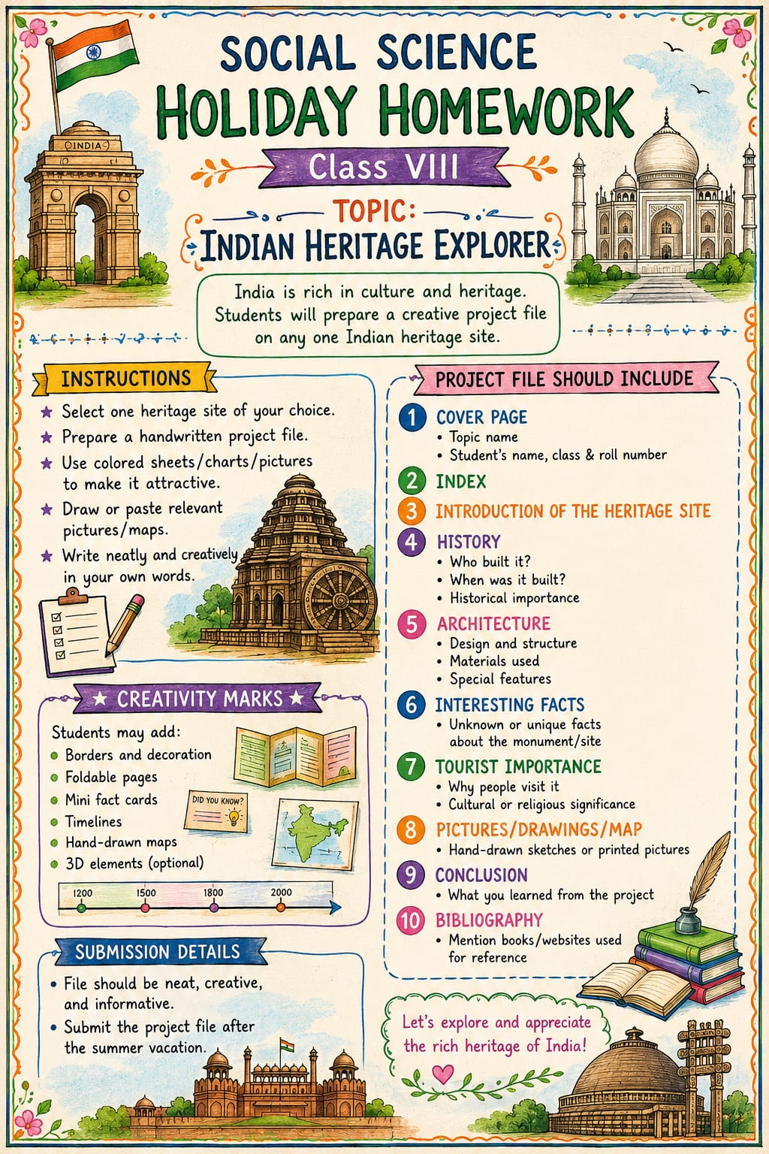

COMPUTER
Make a slide show in Photo App
Topics are:-
- AI Features
- Robot Features with images
OR
Make a A4 sheet based on above topics with full of Graphics

G.K
Learn Question answers ,blanks , true false of lesson 1 to 8.

ART
Make a Best out of Waste. ( Any wall hanging, pen stand, painting with paper bags, recycle bottles etc)

