🌻🌻🌻🌻🌻🌻🌻🌻🌻🌻🌻🌻

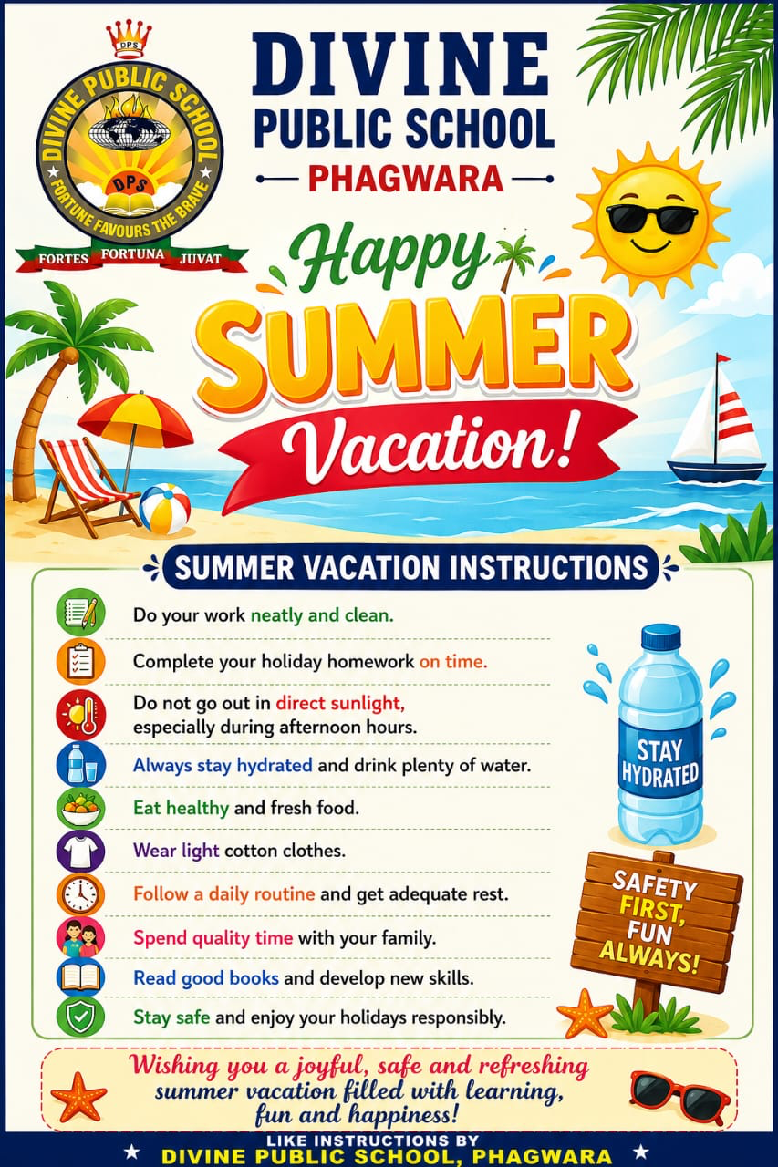

🌺English:Holidays Homework

☑️Grade: 4th

👍1. Reading Practice (Daily – 10 minutes)

Read one page every day from your English textbook/storybook.

Practice:

clear pronunciation

reading with pauses

difficult words

Write 5 new words every week with meanings.

👍2. Chapter Reading
Read all English chapters done in class.

Learn:

difficult words

word meanings

question/answers

Revise notebook work neatly.

👍3. Previous PT–1 Revision

Learn and revise:

✅ spellings

✅ grammar done in class

✅ notebook work

✅ question answers from PT–1 syllabus

👍4. Comprehension Passage Worksheet

Passage 1 – The Honest Woodcutter

A woodcutter lived near a forest. One day he was cutting wood near a river. Suddenly, his axe fell into the water. He became very sad. A fairy appeared and helped him. She showed him a gold axe and a silver axe, but the woodcutter said they were not his. Then she brought his iron axe. The fairy was happy with his honesty and gave him all three axes.

Answer these:

Where did the woodcutter live?

What fell into the river?

Who helped him?

Why was the fairy happy?

Write two describing words from the passage.

Passage 2 – Summer Morning

The sun shines brightly in summer. Children wake up early and enjoy the cool morning air. Birds sing sweet songs in the trees. Many children drink lemonade and eat juicy mangoes. Summer vacation is a fun time for everyone.

Answer these:

When do children wake up?

What do birds do?

Name one fruit from the passage.

Which season is mentioned?

Make one sentence with “summer”.

👍5. Noun Practice Worksheet

A. Underline the nouns:

The cat is sleeping on the chair.

Riya has a blue bag.

My school has a big playground.

The farmer works in the field.

Mangoes are sweet.

B. Write Common or Proper Noun:

Punjab __________

teacher __________

Ravi __________

city __________

India __________

C. Circle the collective nouns:

🌷bunch of grapes

🌷team of players

🌷herd of cows

🌷pack of cards

👍6. Writing Practice

Write neatly in your English notebook:

1. My Summer Vacation – 8 to 10 lines

2. My Favourite Teacher – 8 to 10 lines

3. The Importance of Trees – 8 to 10 lines

4. A Visit to the Park – 8 to 10 lines

Handwriting Practice

5.Write one page every week on any one topic:

*My Family

*My Best Friend

*My School

*My Favourite Fruit

*Summer Season

Use neat handwriting, capital letters, and punctuation marks.

👍7. One Creative Activity

My Favourite Book

Take one chart sheet/A4 sheet and:

paste or draw your favourite book

*write the book name

*write the writer’s name

*write your favourite character

*write 5 lines about the book

Decorate it neatly with colours.

Complete all work neatly in your holiday homework notebook.

Enjoy your holidays! 🌸

🎉EVS: Holiday Homework

☑️Grade: 4th

👉1. Family Tree Activity

Draw your family tree and paste or draw pictures of family members.

Write 2 lines about each member.

👉2. Healthy Food Chart

Make a chart of healthy and unhealthy foods using pictures from old magazines or drawings.

Healthy Food Unhealthy Food

Fruits Chips

Milk Cold drinks

Vegetables Pizza

Salad Chocolates

👉3. Save Water Poster

Make a colorful poster on “Save Water” and write 5 slogans.

Example slogans:

• Water is life

• Save water, save Earth

• Every drop counts

• Don’t waste water

• Use water wisely

👉4. Plant Observation Activity

Plant a seed in a pot. Observe it for 7 days and write changes daily.

Day Observation

Day 1 Seed planted

Day 3 Small sprout seen

Day 5 Tiny leaves appeare

👉5. Cleanliness Pledge

Write and learn this pledge:

“I will keep my home, school, and surroundings clean.

I will throw garbage in dustbins and help keep the environment green.”

👉6. Draw and Color

*Draw any one:

• Solar System

• Traffic Signals

• Sources of Water

• Parts of a Plant

👉7. Write names of:

• 10 animals

• 10 birds

• 10 fruits

•। 10 vegetable

👉8.Oral Work

1. Learn days of the week and months of the year.

2. Learn names of seasons.

3. Learn five good habits.

4. Read EVS chapter daily for 15 minutes.

👉9. Make a “Best out of Waste” craft item.

👉10. Write two difficult words daily from the book in your notebook.

🔯Hindi: Holiday Homework

☑️Grade: 4th

👉• कुछ फलों और सब्जियां के चित्र कॉपी पर चिपकाए और उनके नाम लिखे ।

👉• स्वच्छता के नारे को A4 शीट पर सुंदर रंगों से लिखकर कॉफी पर चिपकाए ।

👉• *प्रोजेक्ट वर्क*

एक A -3 सीट को तो भागों में विभाजित करें और पंजाब तथा उड़िया में मिलने वाले भोजन के पांच पांच चित्र चिपकाकर उनके नाम लिखें।

👉 *पठन कौशल*

अपनी पठन क्षमता को बेहतर बनाने के लिए प्रतिदिन हिंदी कहानी की किताब पढ़ें।

🌼ਪੰਜਾਬੀ :ਛੁੱਟੀਆਂ ਦਾ ਕੰਮ

☑️ਕਲਾਸ: ਚੋਥੀ

🪷ਪੰਜਾਬੀ ਨਵਰੰਗ

ਪੰਜਾਬੀ ਵਰਣਮਾਲਾ ਊੜੇ ਤੋਂ ਲਲੇ ਤੱਕ 5 ਵਾਰ ਲਿਖਣੀ

ਪਾਠ 3 ਅਤੇ 4 ਦੇ ਸ਼ਬਦ ਭੰਡਾਰ ਕਾਪੀ ਤੇ ਕਰਨੇ

ਪੰਜ ਪੇਜ ਸੁੰਦਰ ਲਿਖਾਈ ਦੇ ਕਰਨੇ

🪷ਪੰਜਾਬੀ ਵਿਆਕਰਨ

✍️ਲੇਖ ਸ਼ਹੀਦ ਭਗਤ ਸਿੰਘ ਅਤੇ ਵਿਸਾਖੀ ਕਾਪੀ ਤੇ ਕਰਨੀ

✍️ਫੀਸ ਮਾਫੀ ਦੀ ਅਰਜੀ ਕਾਪੀ ਤੇ ਕਰਨੀ

✍️ਮੁਹਾਵਰੇ 1 ਤੋਂ 10 ਸਮਾਨਾਰਥਕ ਸ਼ਬਦ 1 ਤੋਂ 10

✍️ਘੁੱਗੀ ਅਤੇ ਸ਼ਹਿਦ ਦੀ ਮੱਖੀ ਕਹਾਣੀ ਕਾਪੀ ਤੇ ਕਰਨੀ

🍄ਐਕਟੀਵਿਟੀ ਕਿਸੇ ਪੰਛੀ ਦੀ ਜਾਂ ਜਾਨਵਰ ਦੀ ਤਸਵੀਰ ਬਣਾ ਕੇ ਉਸ ਬਾਰੇ ਬਾਰੇ ਪੰਜ ਲਾਈਨਾਂ ਲਿਖਣੀਆਂ।

🧮 Maths:Holidays Homework

☑️Grade: 4th

⚡️Q:1:-Write and Learn Roman numbers from 1to 40.

⚡️Q:2:- Write and Learn tables from 2 to 15.

⚡️Q:3:- Fill in the blanks:-

1. 1Kilogram = ______ grams.

2. 1Week=______ days.

3. 100 paise=______rupee.

4. The place value of 5 in5,432 ________.

5. A triangle 📐 has ______ sides.

⚡️Q:4:-True or False

1.500 is greater than 50.

2.A square ⬜ has 5 sides.

3.9×4=36

4.Half of 20 is 5.

5.A rectangle has 4 corners.

⚡️Q:5:-Mental Maths:-

1.What comes after 9,999?

2.What is double of 45?

3.What is half of 80?

⚡️4.Write the smallest 4 digit numbers.

5.Write the greatest 3 digit numbers.

⚡️Q:6:-Shapes and Geometry:-

1.Name the shapes with:-

* 3 sides=_____

*4 equal sides=_______

*No corners=_______

⚡️Q;7:- Draw the shapes and colors them.

• A circle

• A rectangle

• A triangle

⚡️Q:8:-Measure the length of 5 objects at home and write their measurements.

⚡️Q:9:-Puzzle Time:-

• I am a number greater than 50but less than 60.My ones digit is 5. Who am I?

• If you add10 tome,I become 100.What number am I?

⚡️Q;10:-Make a colourful chart of different shapes.

🎨Art: Holidays homework ☑️Grade: 4th

🌈 Make a poster on June 21- International Yoga Day. Only A4 or A3 size will be accepted.

📀Computer :Holidays Homework

☑️Grade: 4th

*Draw and color a computer system.

*Paste pictures of 2 Input Devices and 2 Output Devices and write their names.

*Write 5 lines on a Computer.

*Make 4 flash cards:

1.Input Device

2.Output Device

3.Desktop

🔶G.k. Holidays Homework

☑️Grade: 4th

🧤1. Learn and write the names of:

* 10 Indian States and their Capitals

* 10 National Symbols of India

🧤2. Write:

* 10 Famous Personalities of India

* 10 Famous Monuments of India

🧤3. Paste pictures of:

* 5 Birds

* 5 Animals

* 5 Fruits

🧤4. Write 20 General Knowledge questions and answers in your notebook.

🧤5. Read a newspaper daily and write one important news headline every day.

🧤6. Write the names of:

* 7 Continents

* 5 Oceans

🧤7. Prepare a scrapbook on Famous Places of India with pictures.

🧤8. Revise all G.K. chapters done in class.



