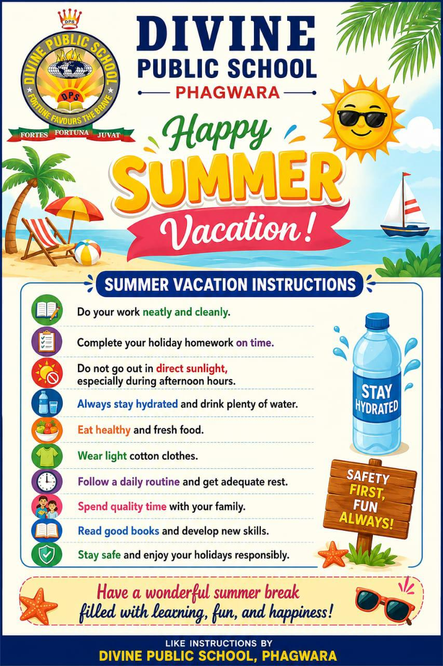
English
READING
Read any one story of your choice and write:
Character sketch of the main character,
Moral of the story and Your favourite scene
WRITING
1. Paragraph Writing on A Memorable Holiday Trip
2. Diary Entry
Write a diary entry on: “The happiest day of my summer vacation.”
3. Letter Writing
Write an informal letter to your friend describing how you spent your holidays.
4. Story Writing
Complete the story using the hints:
“It was raining heavily. I was alone at home when suddenly the lights went out…”
GRAMMAR
Revise and practice:
Tenses
Modals
Active and Passive Voice
Direct and Indirect Speech
Determiners
Activity
Make a colourful grammar chart on any one topic.
LISTENING
Listen English news for 10 minutes daily.
Note down 5 new words with meanings.
SPEAKING
Prepare a 1–2 minute speech on any one topic.

Hindi
Revise full syllabus of pt1
कोई 20 मुहावरों को अर्थ सहित वाक्यों में प्रयोग करते हुए सुंदर लिखाई में एक प्रोजेक्ट फाइल तैयार करें और उनको याद करें।
Activity_संत कवि रविदास का जीवन परिचय और उनके पद सुंदर लिखाई में चित्र सहित लिखे ।
Roll No. 1 to 14
सुभद्रा कुमारी चौहान का जीवन परिचय और उनकी कविता झांसी की रानी को सुंदर लिखाई में चित्र सहित लिखें।
Roll No. 15 to 29
Do on chart paper

Punjabi
ਨੋਟ - ਹੇਠ ਦਿੱਤੇ ਵਿਸ਼ਿਆਂ ਦੀ ਫਾਈਲ ਬਣਾਓ ਘੱਟੋ ਘੱਟ 10 ਪੇਜ਼ ਤੇ ਸੰਬੰਧਿਤ ਤਸਵੀਰਾਂ ਲਗਾਓ।
ਨਾਮ -
ਰੋਲ਼ ਨੰਬਰ -
ਜਮਾਤ -
ਸਕੂਲ ਦਾ ਨਾਮ-
ਵਿਦਿਆਰਥੀ ਦਾ ਨਾਮ
ਅਧਿਆਪਕ ਦਾ ਨਾਮ
Roll Number 1 to 5.
ਪੰਜਾਬ ਦੇ ਮੇਲੇ ਦੇ ਤਿਉਹਾਰ।
Roll Number 6 to 10.
ਕਰੋਨਾ ਕਾਲ ਵਿੱਚ ਲੋਕਾਂ ਦੀ ਆਰਥਿਕ ਤੇ ਮਾਨਸਿਕ ਸਥਿਤੀ।
Roll Number 11 to 20.
ਅਜੋਕੇ ਸਮੇਂ ਵਿੱਚ ਬਜ਼ੁਰਗਾਂ ਦਾ ਘੱਟ ਰਿਹਾ ਸਤਿਕਾਰ ਆਪਣੇ ਵਿਚਾਰ ਪੇਸ਼ ਕਰੋ।
Roll Number
21 to 25
ਕਰੋਨਾ ਕਾਲ ਸਮੇਂ ਪੇਂਡੂ ਅਤੇ ਸ਼ਹਿਰੀ ਜੀਵਨ ਦਾ ਅੰਤਰ।
Roll Number 26 to 29
ਕਰੋਨਾ ਕਾਲ ਸਮੇਂ ਉਭਰੀ ਲੋਕ ਸੇਵਾ ਤੇ ਭਾਵਨਾ।

SCIENCE
Physics
1. Complete your Science Lab Manual.
2. Solve the worksheet shared in the group on loose sheets.
Note: All work should be completed neatly and submitted on time.

Chemistry
Rollno.
1 to 5 = make model on cycle material
6 to 10 = make model on electrochemical cell
11 to 15 = make working model on pollution control system
16 to 20 = make working model on chandryan -3
21 to 25 = working model of Robert
26 to 29 = working model on chandryan -3

Biology
*Notebook Work*
Draw well-labeled diagrams of a Plant Cell and an Animal Cell in your *Biology Notebook.*

*Model Assignment*
Roll no: 1-5
Plant cell and animal cell model
Roll no: 6-10
Windmill model
Roll no. 11-15
Structure of human kidney
Roll no. 16-20
Photosynthesis model
Roll no. 21-25
Grassland ecosystem model
Roll no. 26-30
Pond ecosystem model

Mathematics
Instructions:
Complete the following work neatly and submit it after the holidays.
1. Complete your Mathematics Lab Manual with all pending activities and practical work.
Note:-(Do first 10 activities/practicals).
2. Prepare a Formula Book by writing all important formulas from your Mathematics textbook chapter-wise in a separate notebook. Decorate and organise it neatly for future revision.
3. Revise the complete PT-1 syllabus thoroughly and practise important questions for better understanding and preparation.
Note: All work should be completed neatly and submitted on time.

Social Science
Holidays Homework
- Prepare a project on Natural and Man-made disasters.

COMPUTER
1. Digital Documentation (LibreOffice Writer)
Create a 1–2-page document on “Importance of Information Technology in Daily Life”.
• Use heading and sub-headings
• Use bold, italic, and underline
• Insert one image and one table
• Save the file as IT_Holiday_HW.odt

2. Electronic Spreadsheet (LibreOffice Calc)
Create a monthly expense sheet for your family.
• Minimum 5 expense categories
• Use SUM and AVERAGE formulas
• Insert one bar or pie chart

3. Presentation Skills (LibreOffice Impress)
Prepare a 5–6 slide presentation on “Cyber Safety for Students”.
• Title slide
• Do’s and Don’ts
• One image
• One slide with your own ideas

